**What is the operating system**?

The operating system is the interface between the user and computer hardware. The hardware of the computer cannot understand the human-readable language as it works on binaries i.e. 0’s and 1’s. Also, it is very tough for humans to understand the binary language, in such cases we need an interface that can translate human language to hardware and vice-versa for effective communication.

Types of operating systems:

**Single user – Single tasking operating system**

In this type of operating system, only one user can log into the system and can perform only one task at a time.

Ex: MS-DOS

**Single user – Multi-tasking operating system**

This type of OS supports only one user to log in to the system, but a user can perform multiple tasks at a time. Browsing the internet while playing songs etc.

Ex: Windows-98, XP

**Multi-user – Multi-operating system:**

This type of OS allows multiple users to log into the system and each user can perform various tasks at a time. In a broader term, multiple users can log in to the system and share the resources of the system at the same time.

Ex: Linux, Unix, etc.

**What is the Unix**?

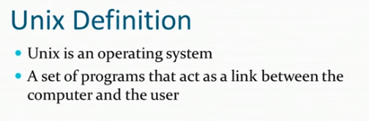

**What is the Shell?**

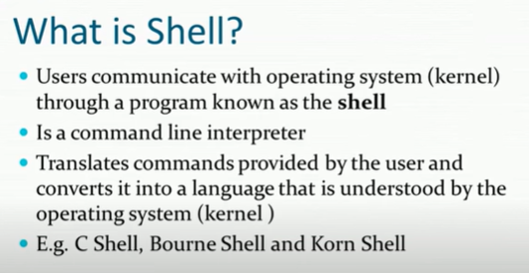

What is the Kernel?

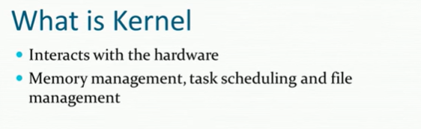

**Unix architecture:**

The architecture of Unix can be divided into three levels of functionality. The lowest level is the kernel, which schedules tasks, manages resources and controls security. The next level is the shell, which acts as the user interface, interpreting user commands and starting applications. The highest level is the utilities, which provide utility functions. In other words, it is the User level, as the user is the one who operates those utilities.

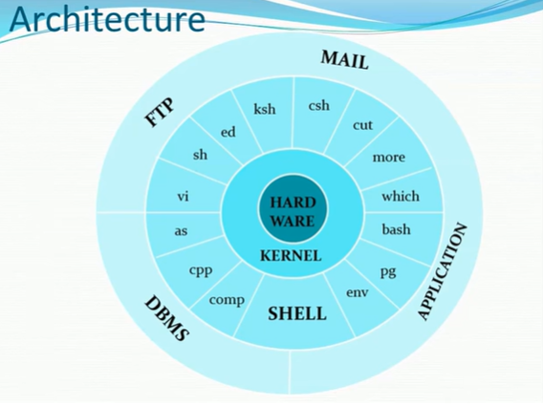

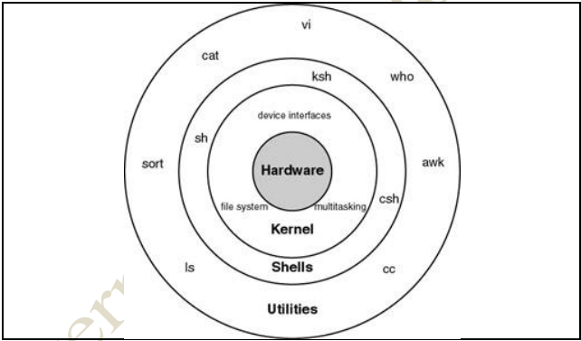

**Linux boot process:**

when you turn on your machine there has to be a whole series of different processes that effectively build on each other, so that we eventually get to a fully functioning Linux system.

The first thing is bios, bios (basic input output system).

*When we push the power button on our laptop or on our desktop computer, the bios is the piece of software that runs first, which is going to perform us called Post (power on self-test). that will do an integrity check (that will check hardware components like CPU, RAM, storage devices, and peripherals. If any issues are detected, error messages may be displayed.) BIOS then searches for a bootable device, typically the hard drive, SSD, or an external bootable device like a USB drive.

Keynote: bios runs from ready-only memory (ROM), that effectively comes from the motherboard of your computer. BIOS is independent of the operating system.

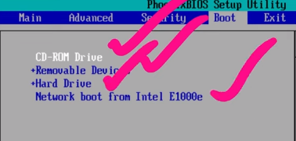

Then BIOS will go to the CD-ROM drive and does check if there is MBR (master boot record). Then if CD-ROM does have the MBR then it will attempt to load the operating system from CD-ROM.

If not it will go to other options like removable device and etc from the above image.

Then MBR will run the bootloader and MBR has only 512 bytes.

MBR will provide the information related to the bootloader.

MBR has two types of bootloaders one LYLO (Linux loader ) and GRUB(Grand Unified bootloader)

LYLO will used for only Linux-based operating systems where whereas GRUB will used for various operating systems.

When you have 2 operating systems when GRUB loads up you can actually choose which system you want to boot up(windows or Linux)

The main purpose of GRUB is to load the kernel into the memory (RAM)

Once we are done with that then we will have a stage called kernel initialization

*The Linux kernel is loaded into memory and begins its initialization process

*The kernel performs hardware detection, initializes essential system resources, and mounts

*Kernel parameters passed by the bootloader (such as "root=" and other kernel options) are processed during this stage

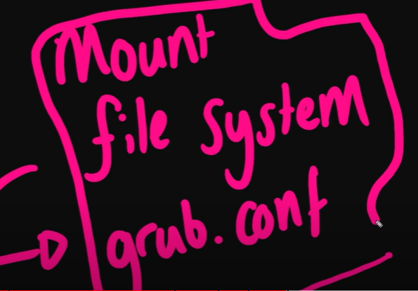

then finally kernel is going to load the “systemd”

The kernel, after mounting the root filesystem, hands control over to the init process, which is the first user-space process to run. In modern Linux distributions, the init process is often replaced with Systemd, but older systems may use SysVinit. The init process initializes system services, daemons, and user-level processes based on the runlevel or targets specified.

File system in Linux:

If you can enter

Cd /

Then you will see the file structure in Linux OS.

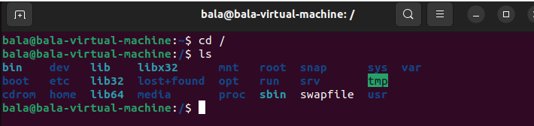

**Bin(Binaries):(/bin)**

Which contains binaries or Essential executables that are essential to the entire operating system.

You can these binaries from the command line at any time.

Ex: vim, ls, gzip, crontab

**Sbin (system binaries):(/sbin)**

It contains system binaries that should only executed by super user (root).

Ex: delgroup, deluser

**Libraries:(/lib)**

It contains shared code between libraries.

Ex: udev, ufw

**User binaries(/usr):**

It contains non-essential binaries

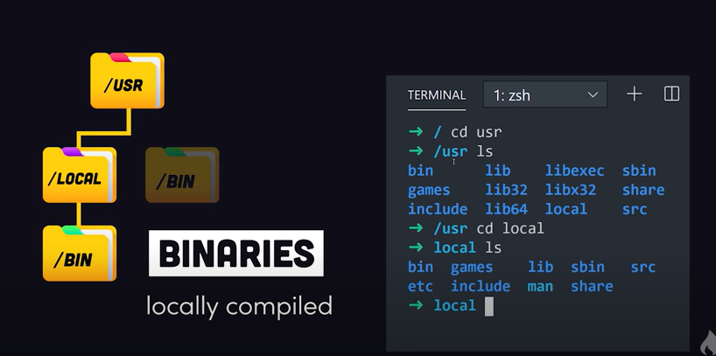

All libraries are mapped by $path variable, that is you can execute those binaries from any folder and from any terminal.

*If you never know where the binary is, use the which command.

**Command: Which curl**

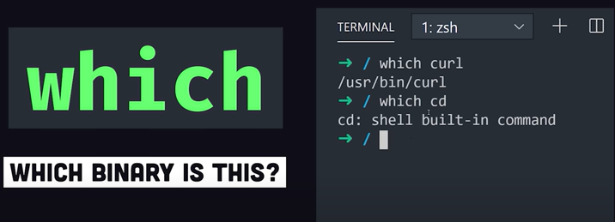

**Etc (/etc):ET Cetera: Editable test config:**

Somepoint you may want to customize the behaviour of the software on your system

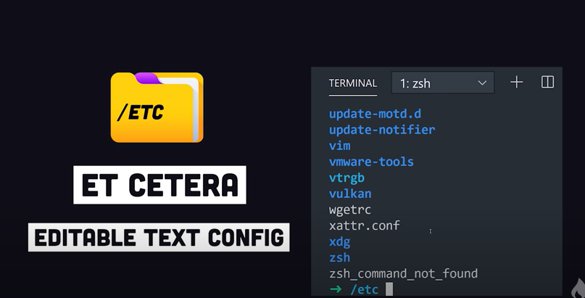

As an operating system it will support multiple users and you can go to home directory of the root user and use ls it will give the users data on it.

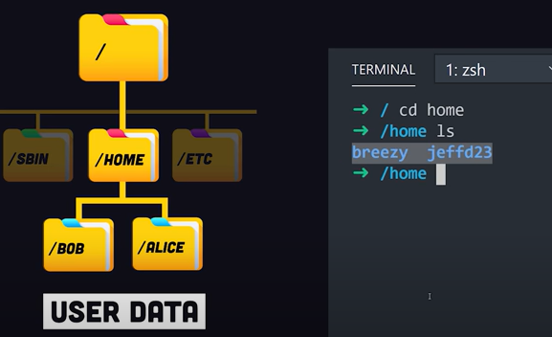

**Shortcut to the home :**

~ cd /

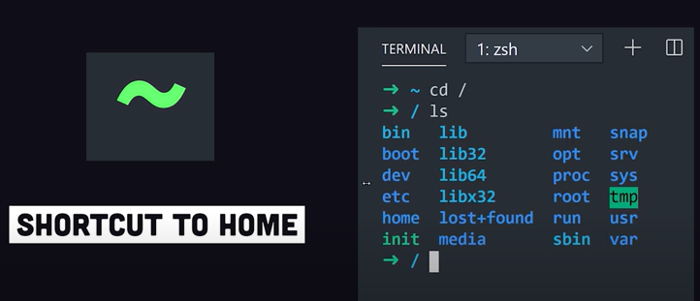

**Boot (/boot):**

It contains the files to boot the system like the Linux kernel etc.

**Dev(/dev):**

It stands for device files and here you can interface with hardware, drivers.

You can create disk partitions here.

OPT (/opt):

It contains optional or add-on softwares and you rarely interact with them.

VAR (/var):

Var contains variable files that change while the operating system is used.

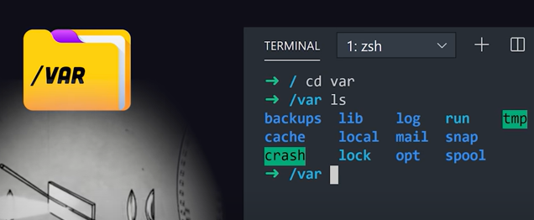

**TEMP(/tmp):**

Contains temporary file that will not persist during reboot.

**PROC (/proc):**

Actually proc directory does not exist on the disk but it create memory on the fly by the linux kernel to keep track of the processes that are running on the system.

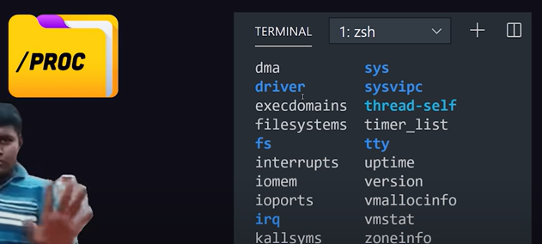

**ls**

By using the ls command, we can list out the contents of the folder or directory.

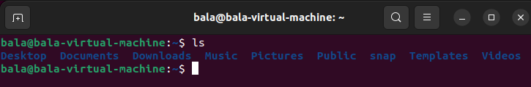

**ls -l**

It is used to list files and directories in a directory, providing detailed information about them in a long format.

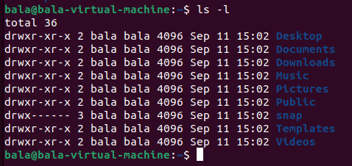

**ls -la:**

using ls -la ,you get a long-format listing that includes all files and directories, including hidden ones.

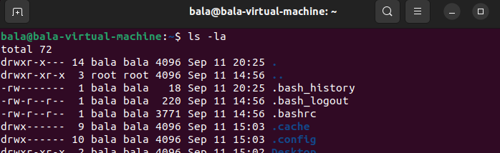

**Pwd:**

Which shows the present working directory.

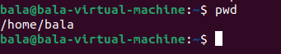

**Cd ..:**

It will change your folder to one level up.

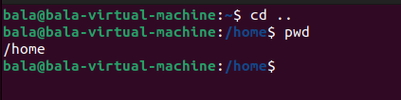

**Cd :**

It will throw us to the home directory.

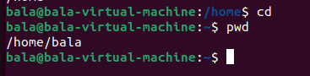

**Touch:**

If you want to create an empty file, use the touch command.

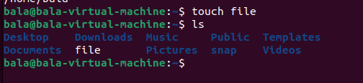

**Cat:**

if you want to create file with some content , use cat command.

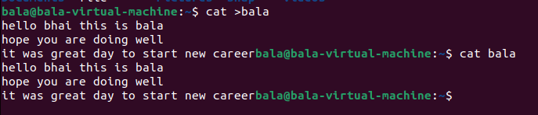

Concatenating multiple files using cat, and saving them into new file “balabro”

Note: **Cat** stands for concatenating

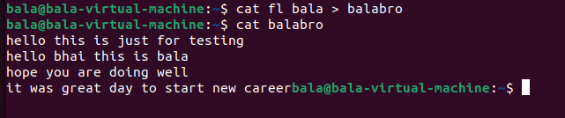

If you want to edit or append the text to the existing file, use the following command.

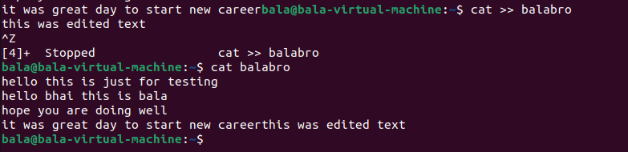

To create a directory , use the following command



Note: Don’t use space while creating a folder, if you do it, it will create two folders

Ex: mkdir balu dir



To create multiple folders at a time use the below cmd.

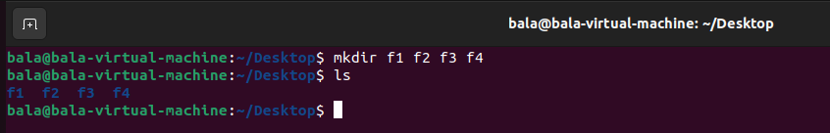

To clear the content on the screen or on the terminal

One way is to use the “**Clear**” command. And another way is to use **“ctrl + n + l”**

**If** you want to copy the files from one location to another,, use

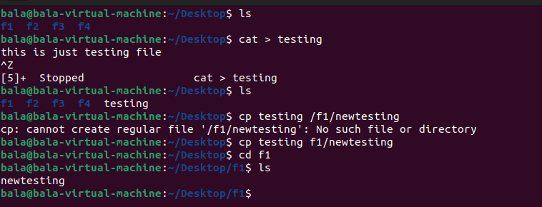

To move a folder from one location to another

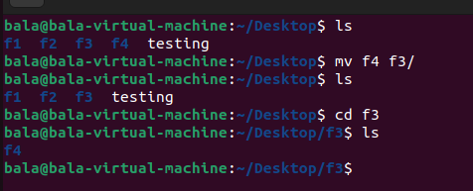

To remove a file from the folder, use the following command.

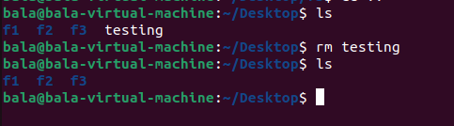

If you want to remove an empty directory, use the

**rmdir foldername** command and if there are any files in the folder use the

**Rm -rf foldername**

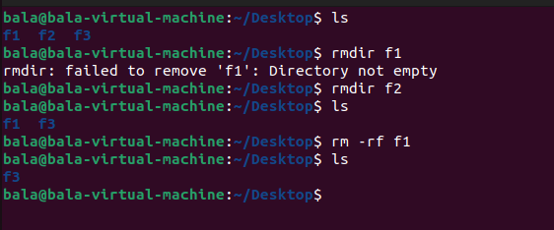

To rename the filename, use the

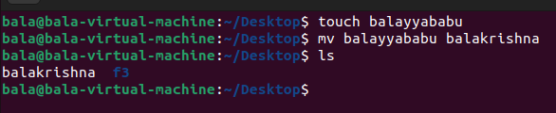

And if you want to hierarchy folders use the below command. And to list out use the **ls -R**

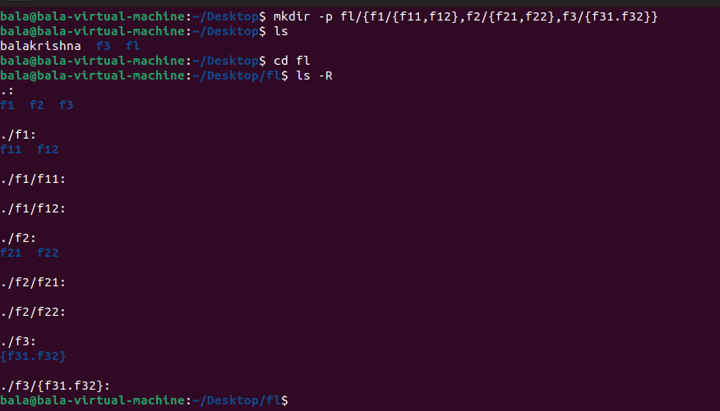

if you want to update the timestamp for the created file, use the touch command

If you specify the name of an existing file as an argument to touch, it will update the file's timestamp to the current date and time without modifying the file's content. This can be useful when you want to mark a file as recently accessed or modified**.**

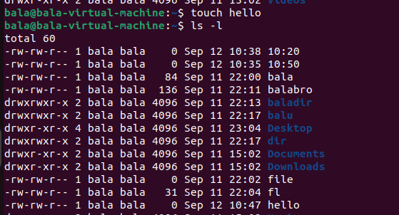

**Create Files with Specific Timestamps:**

You can also use the **-d** option to specify a date and time for a file's timestamps when creating it.

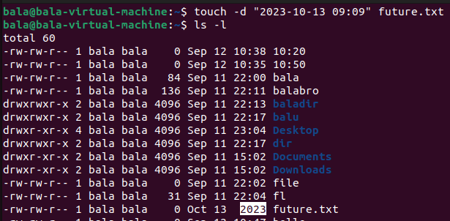

**ls -ltr**

When you run ls -ltr in a directory, you'll get a long-format listing of files and directories, with the oldest items listed at the top and the most recently modified items listed at the bottom. This can be useful when you want to quickly identify the files that have been modified most recently or if you want to see a historical view of the files in a directory.

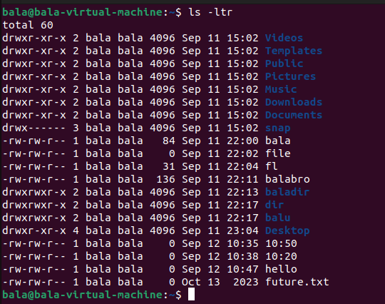

**Head**

The head command will display the first 10 lines from the given file.

Here I have a file with contents from f1 to f30, By using the following command it will display only the first 10 lines from the filetest file.

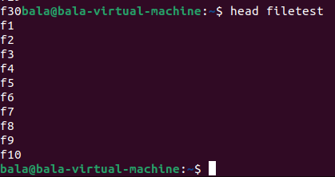

**Tail**

The tail command will display the last 10 lines from the given file.

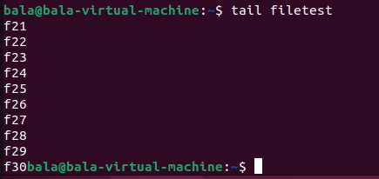

If you want to fetch only 5 lines from the file, then use the following command.

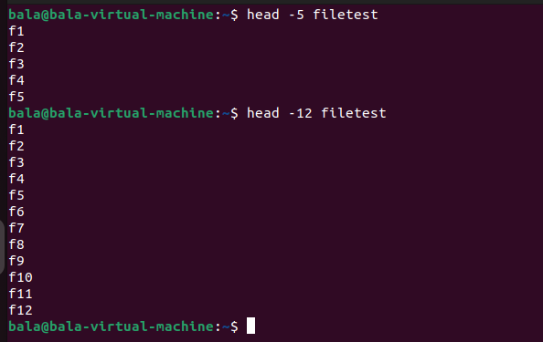

**SED:**

The sed command, which stands for "stream editor," is a powerful text-processing tool available in Unix-like operating systems, including Linux. sed is used for performing various text manipulation tasks on input text (usually from files or pipelines) and generating output based on specified rules or commands. It is particularly useful for tasks like search and replace, text transformations, and editing files without opening them manually.

Display the lines from line number 5 to 10 from the filetest file.

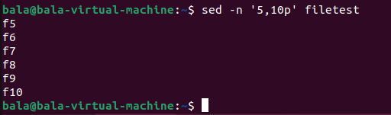

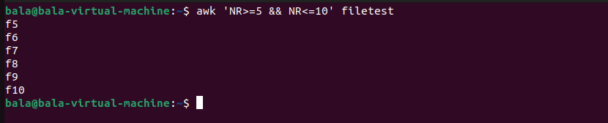

And

Search “**hello”** from testf1 and replace it with “**hi**”



Using echo command with sed.

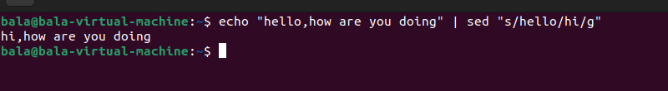

**Tac:**

tac is just reverse to the cat, it will display the contents from the reverse order of the file.

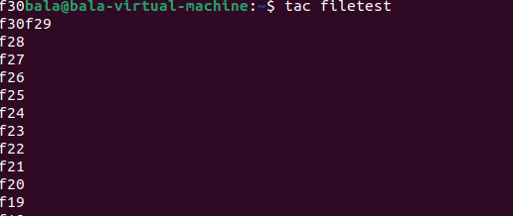

**More**:

If the content is beyond the screen space, then use the “more” command.

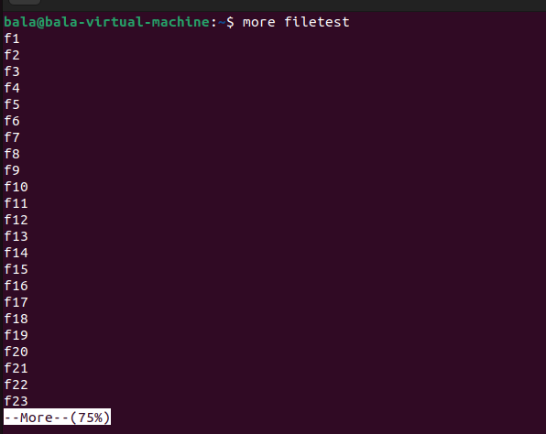

then type the “enter” command to display the remaining content

**id:**

it displays the ID of the user\group

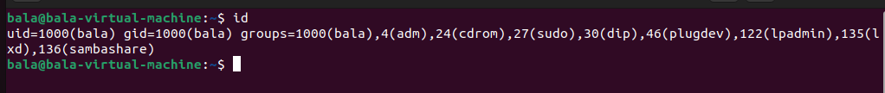

**Grep:**

Grep (global regular expression print) is a filter to search the given pattern in the file content.

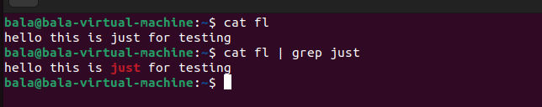

**Diff:**

It will compare the contents of two different files.

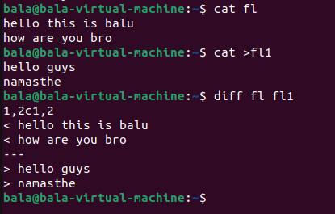

**Ping:**

Checks the connectivity status of the server.

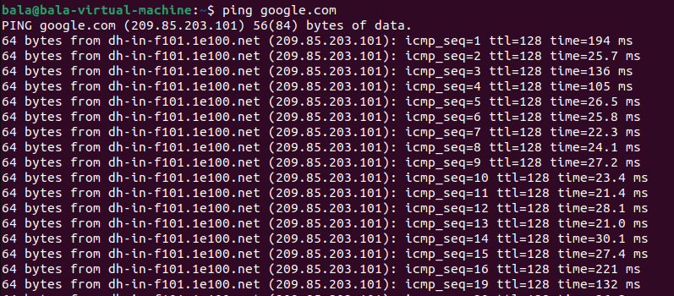

**History:**

The history command will review all commands which you have entered.

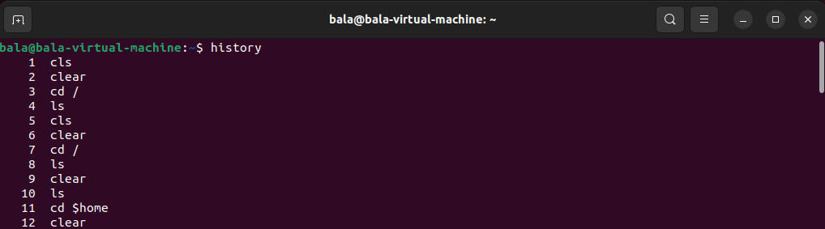

**Hostname**:

Which will display the hostname of the machine.

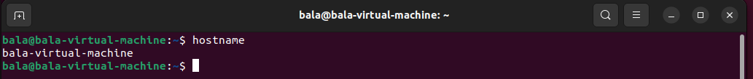

**Host Ip-address:**

Which will display the host machine's IP address.

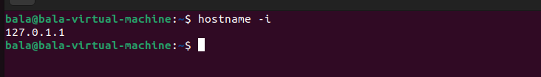

**Chmod**:

chmod is used to change the user/group permissions to access the file.

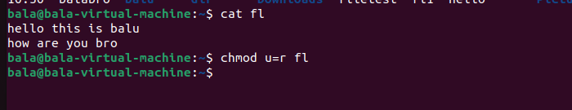

**nl:**

nl command used to give line number to the file content.

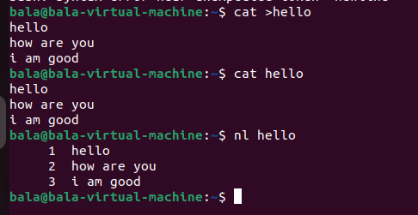

**Tee**:

If you want to display the content on the screen while appending to the file, use the following command.

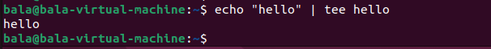

**WC:**

Gives the number of lines, words, and characters available in the file content.

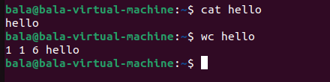

Uniq:

It will remove the duplicates of the file content or it will remove only content if is continuously duplicated.

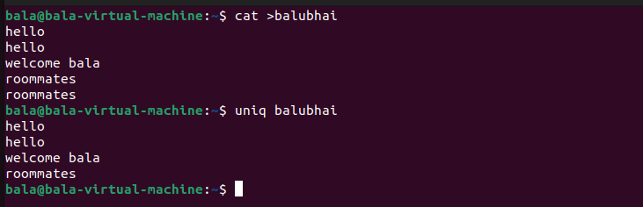

**VI EDITOR:**

This is the command mode editor for files.

It has 3 modes.

1. command mode

2. Insert mode

3. Extended command mode.

**Note**: If you open the vi/vim editor, it will be in the **command mode** by default.

You can open the file in vi editor in 2 ways

Vi filename then enter or else just vi enter

When you open first, by default it will be in command mode .. for that you can switch back to insert mode to edit and give the content to the file.

**For Command mode – (press ESC)**

**For insert mode – (press i/I)**

In insert mode enter some content in it and now

Operations:

Press ESC, now then it will change to command mode

Press l to navigate the cursor from left to right

Press h to navigate the cursor from right to left

Press k from bottom to top

Press j from top to bottom

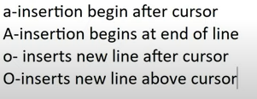

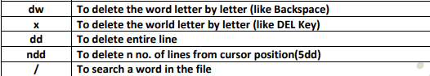

dw – deletes the word

x – deletes letter by letter



After writing the script in vi editor the following operations will get involved to save/quiet .

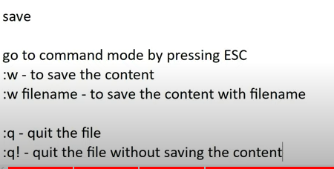 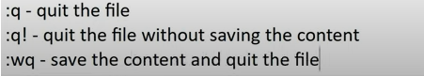

To avoid the case sensitivity with the grep command. Use the following way

Cat /etc/passwd | grep -i bala

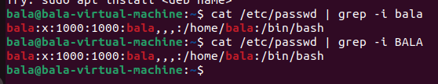

Display the word and 2 lines after the word

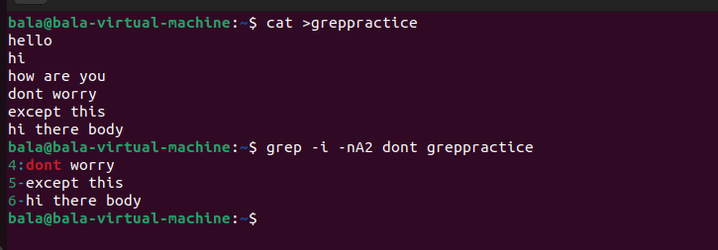

Display the word and 2 lines before the word

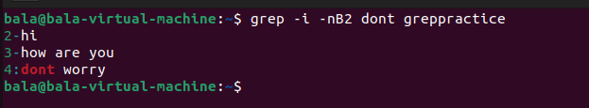

Display the things except the given word.

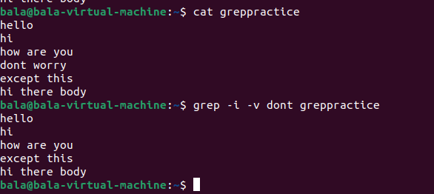

To display the searched word in color

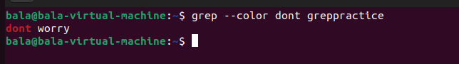

**Top command:**

The top command is used to display the Linux processes.

It gives a real-time view of the running system.

The output or result of the top command will be categorized into 2 half

The first half will be the summary or statistics of the processes and the lower half will contain the list of the running processes.

**User & group related:**

Create the user and password for the same user. and check if a user is created or not using

cat /etc/passwd

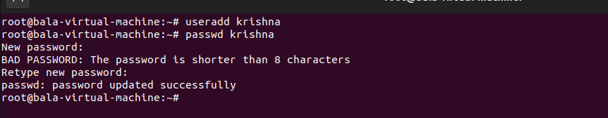

And create the group and check if the group is created or not using the following command.

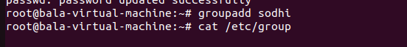

And the newly created to the newly created group using the following command

gpasswd -a username groupname

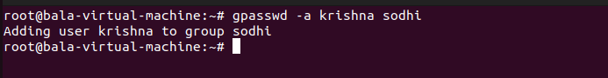

Now I will create a new text file and change the file permissions to the newly created one.

Here I created a file and checked the permissions for it

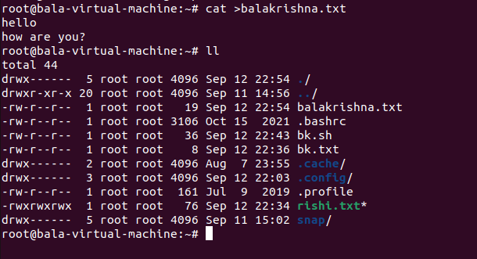

Here

“d” means directory

And

-rw- r- - r- - means

Here first entry will tell you that whether file or folder

Then next 3 entries related to owner of the file

Then next 3 entries related to group of the file

Then next 3 entries related to other of the file

And

Read – 4

Write – 2

Write – 1

Now I changed the permissions using the

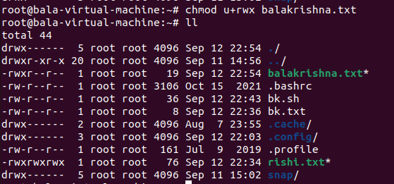

Now I changed the permissions of the file of **users -all permissions** and for the **group I gave read& write** and for **others no permissions.**

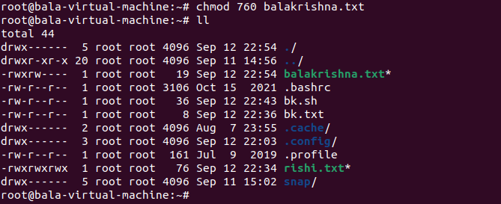

Now I will revoke all permissions to the Balakrishna file, using the following command.

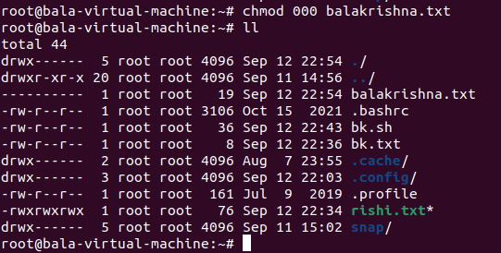

And give all permissions to the users, groups and others using the literals

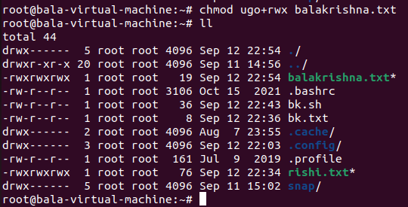

**Tar:**

The tar command in Linux is used for creating and manipulating tarball archives. A tarball is a compressed archive file that can contain one or more files or directories. The name "tar" stands for "tape archive”.

For compressing the files in directory , use the following command

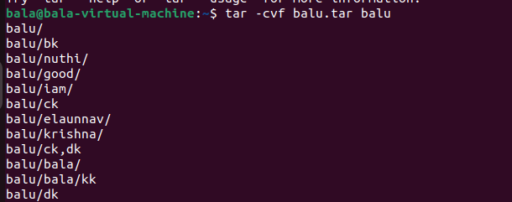

Here

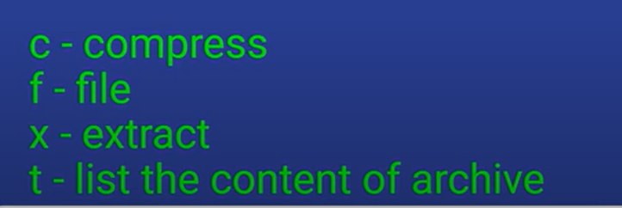

And “v” is verbose

And to list out the contents of the .tar file

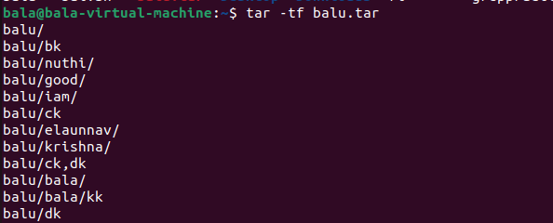

Now, it’s time to extract the tar file to the **same location** using the following command

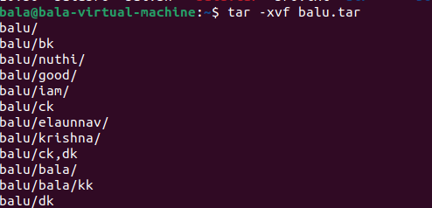

And extract the tar file to a different location, To extract a tarball into a different location in Linux, you can use the -C (change directory) option along with the tar command

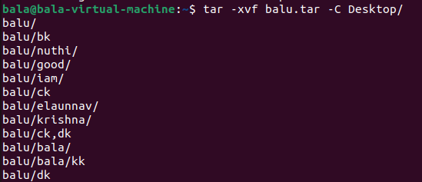

**Compression with Tar and zip at the same time:**

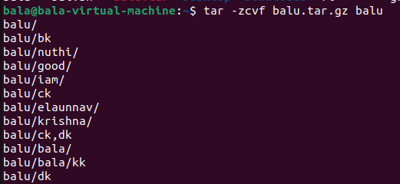

**Extraction with tar and zip at the same time**.

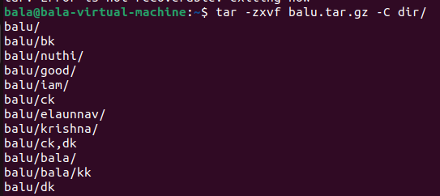

Here

* -c: Create a new archive.
* -x: extract the archive.
* -z: Use gzip compression.
* -v: Verbose mode (optional, for displaying the progress).
* -f: Specify the name of the output archive file.

**Gzip**:

gzip is a compression utility in Linux that is typically used to compress individual files, not folders or directories.

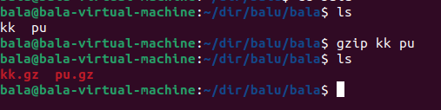

To extract the .gz file

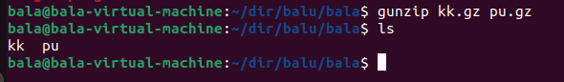

**Whoami vs who:**

Whoami tells you about who you are logged into the machine (username). That tells the currently logged username.

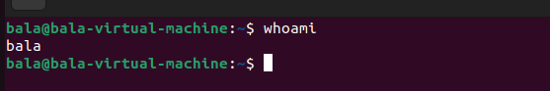

Now, using who will tell in detail like who the user you are, from which terminal you connected, and the connection established date and time. finally Ip address of the machine from where you connected.



**Home:**

You can find the home directory of the currently logged-in user using the echo command with the HOME environment variable:

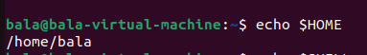

**User's Shell:**

To see the shell being used by the currently logged-in user, you can use the echo command with the SHELL environment variable:



If you want to see which shell is enabled by default,

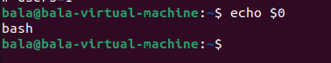

If you want to see how many users logged into my system (count)

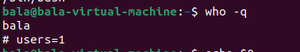

**Who** command with the human-readable format.

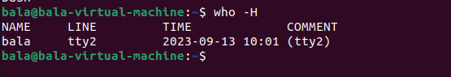

**Uname**:

The uname command in Linux is used to display system information and details about the current operating system.

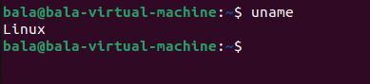

**Uname -a**

This option displays all available information about the system, including the kernel name, network node hostname, kernel release, kernel version, machine hardware name, and processor type.



**Uname -s:**

**s (or --kernel-name):** This option displays the kernel name (e.g., "Linux"):

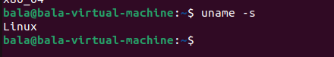

**Uname -n:**

**-n (or --nodename):** This option displays the network node hostname.

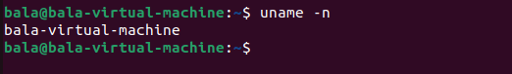

**Uname -r:**

**-r (or --kernel-release):** This option displays the kernel release:

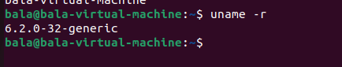

**Uname -v:**

**-v (or --kernel-version):** This option displays the kernel version:

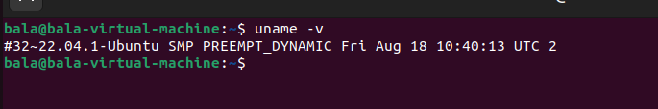

**Uname -m:**

**m (or --machine):** This option displays the machine hardware name (e.g., "x86_64" for 64-bit architecture):

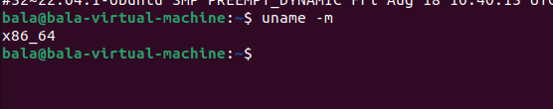

**Uname -p:**

**-p (or --processor):** This option displays the processor type:

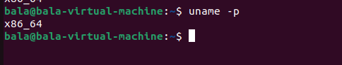

**Uname -i:**

**-i (or --hardware-platform):** This option displays the hardware platform (if available):

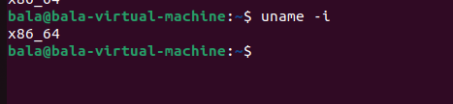

**Uname -o:**

**-o (or --operating-system):** This option displays the operating system name:

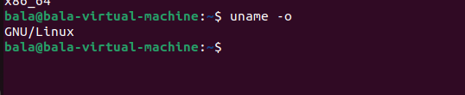

**Disk space related:**

Df command will command in Linux is used to display disk space usage information for mounted file systems.

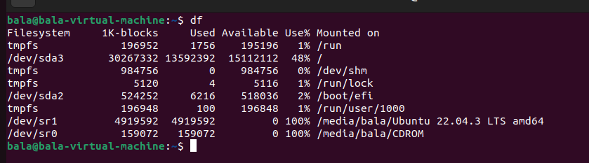

**Df -h:**

**-h (or --human-readable):** This option displays sizes in a more human-readable format, using units like "K," "M," or "G" for kilobytes, megabytes, and gigabytes, respectively.

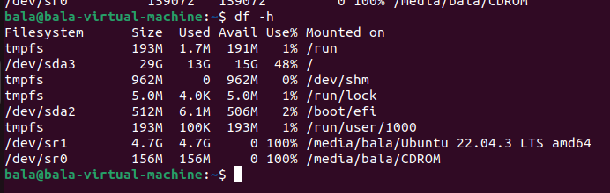

**-T (or --print-type):** This option displays the type of each filesystem.

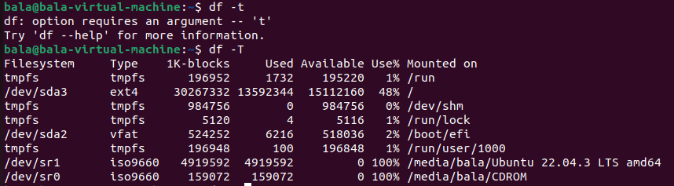

**-a (or --all):** This option displays information about all filesystems, including those that are not mounted.

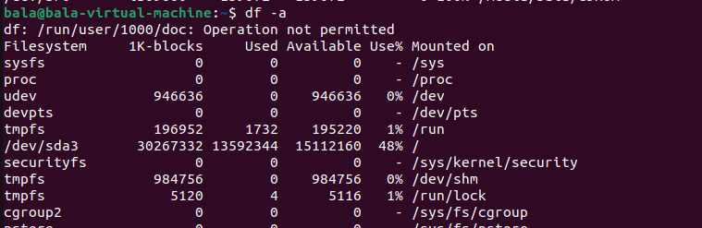

**-x <filesystem-type>:** This option excludes filesystems of a specific type. For example, to exclude filesystems of type tmpfs, you can use:

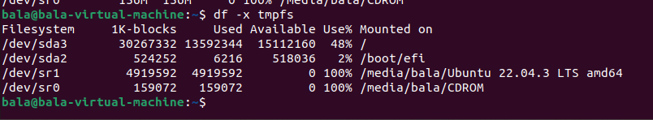

Use **df . -h** to see the disk space information in the current directory.

**du** command shows the amount of disk space used by the specific files and sub-directories.

By default when you use the **du** command it will list out the disk space usage of the current directory

In 1024 bytes format.

If you want to see the summary of the particular directory

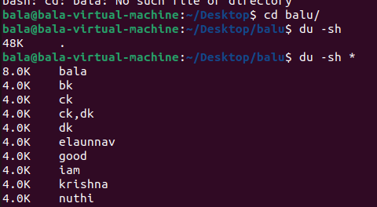

If you want to show the grand total of the directory, use the

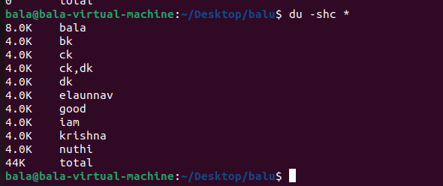

Use the sort command to sorting the size

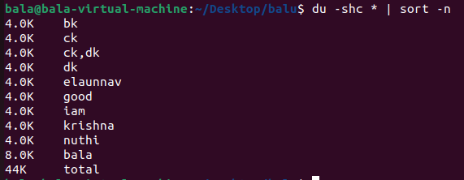

If you want to sort the result in the reverse order

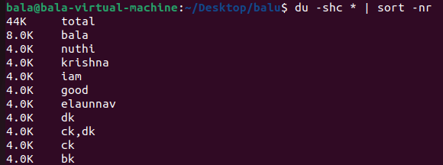

If you want to see only the total, use the following command.



**Free:**

Free command is used to display the total no of free and used physical and swap memory in the system, as well as the buffers and caches used by the kernel.

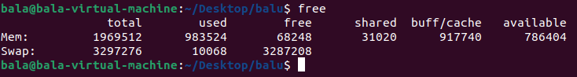

**Cron job:**

Crone daemon is a built-in Linux utility that runs processes on your system at a scheduled time.

Crone reads the crontab (Cron tables) for predefined commands and scripts.

If you want to check the ubuntu installed version.

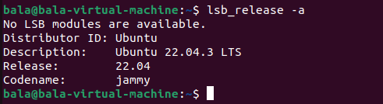

To check if there are any crontab installed or not (using listing option -l)

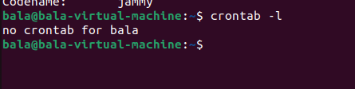

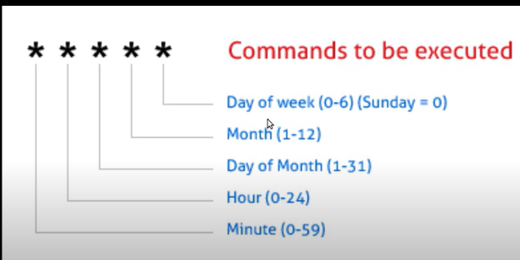

If you want to change the default editor to different use the,

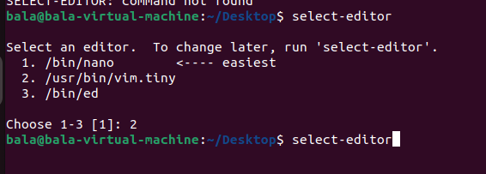

Once the Vim editor is opened you need to give the crontab job details.



Then give the job entries like

Minutes(0-59) hours(0-24hrs) dayofmonth(0-31) month(1-12) dayofweek(0-6) /bin/sh /home/bala/Desktop/abc.sh

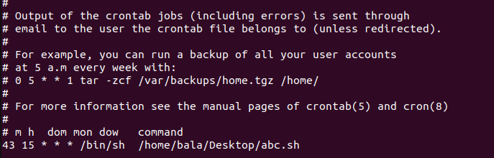

Now open the **abc.sh** file in the **vi editor** and write some commands to execute.

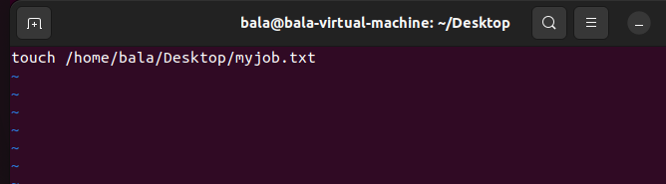

After some time, once the job was run successfully, we can see the myjob.txt file.

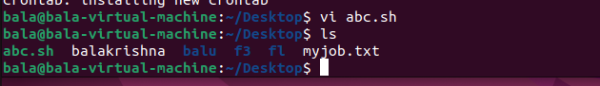

**Networking Commands:**

The first command is ifconfig, which will show all the available interfaces.

Before that if you want to deal with network-related stuff,

You must install **“net-tools”**

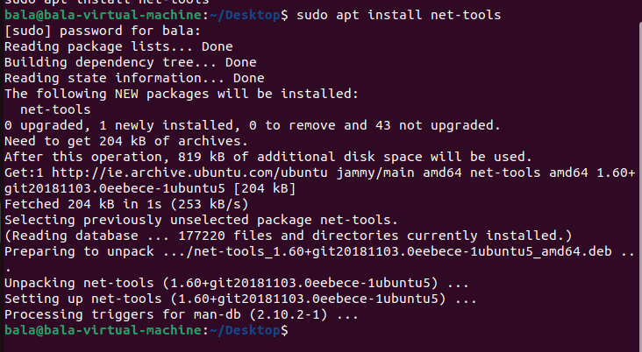

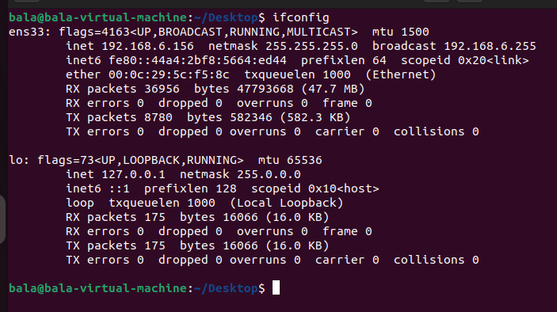

And if you want to see where these files are exactly located

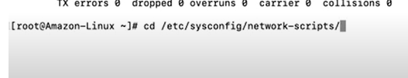

If you want to see a particular interface, you can

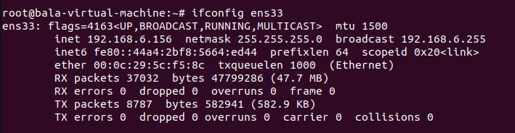

If you want to down the interface , you the

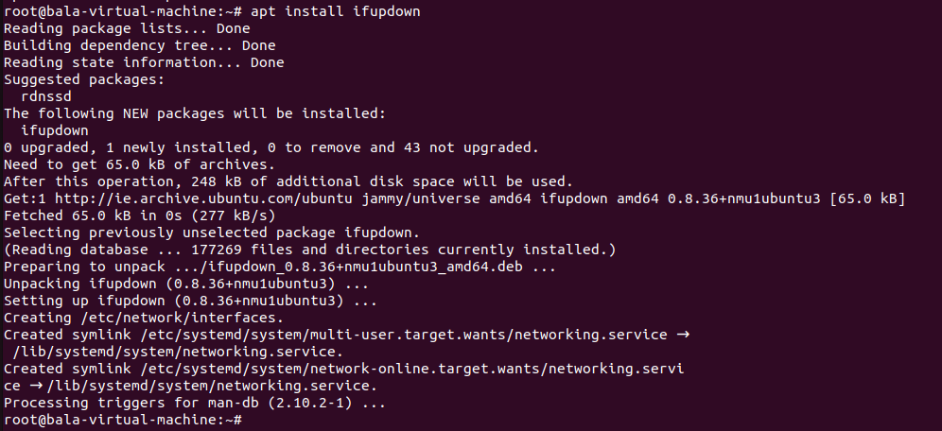

Then if you want to down the particular interface

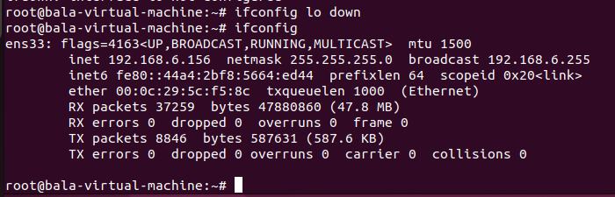

And if you want to **up** the interface, then use the following command

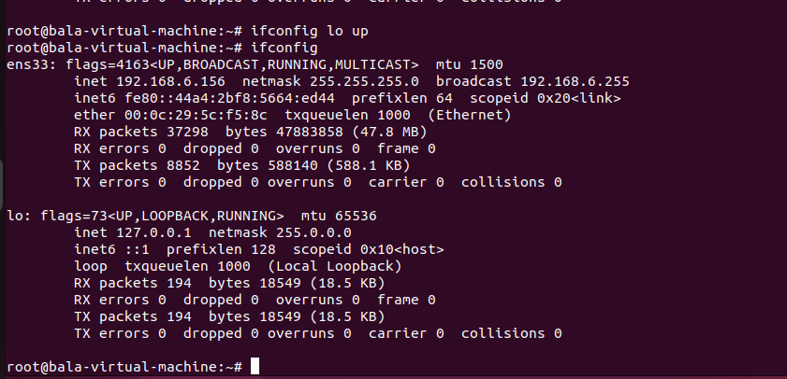

The **ping** command is used to check the connectivity between 2 systems. Whether the system is reachable or not

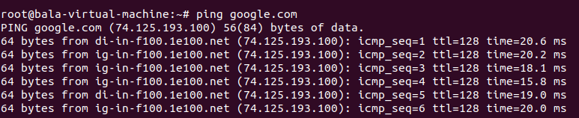

If you want to send only three packets then use the following command.

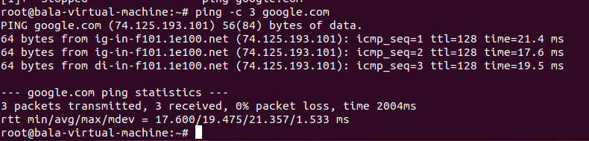

**Traceroute:**

traceroute command in Linux prints the route that a packet takes to reach the host. This command is useful when you want to know about the route and about all the hops that a packet takes.

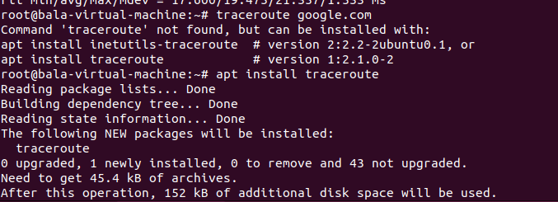

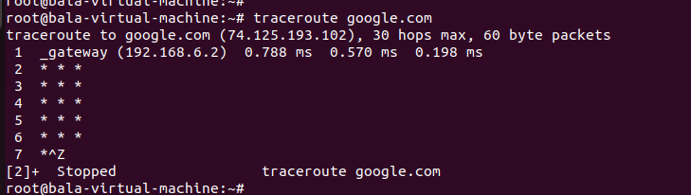

**Netstate:**

Netstat is a command line utility for Linux that prints network connections, routing tables, interface statistics, masquerade connections, and multicast memberships. Netstat can be used to diagnose network issues and service problems.

If you want to see all open ports on the network system. Use

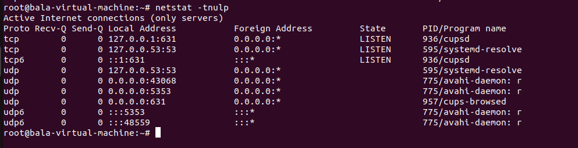

If you want to see routes and gateways

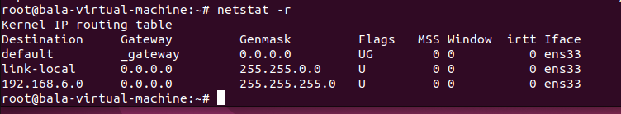

**Dig command :**

Domain information groper is used for retrieving information about DNS name servers

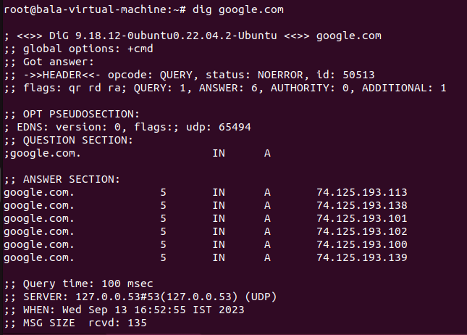

**nslookup** is a command-line tool to retrieve a domain's information, including its IP address and DNS record. To use this tool, enter “nslookup” in the Command Prompt or Terminal. Using various nslookup commands, you will get different information about your domain. This can help troubleshoot DNS-related issues.

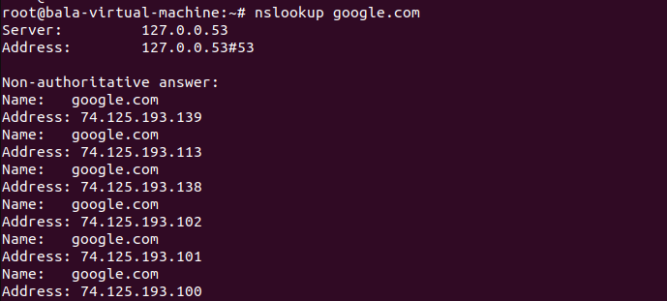

Route :

If you want to see route information, use the

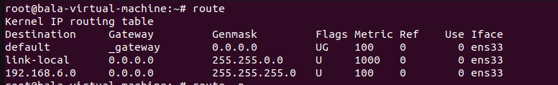

This is just like **netstat -r**

And if you want to see **the IP address of the route(gateway ip address)**

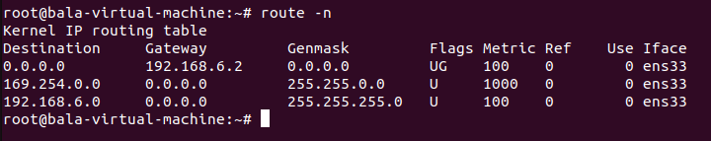

**Host** command is used to check all associated commands with your domain.

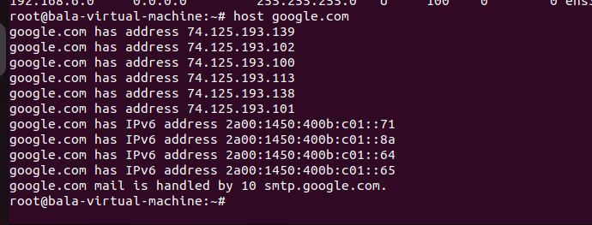



If you want to see hardware and Mac information use the address resolution protocol

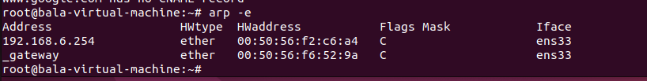

If you want to figure out the hostname. Use

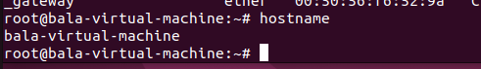

If you want to see the host's IP address, use the

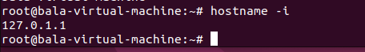

If I want to know what are the particular ports that are listening to this operating system and what is the peer IP address of the system, we can get this kind of detail using the following command (socket statistics).

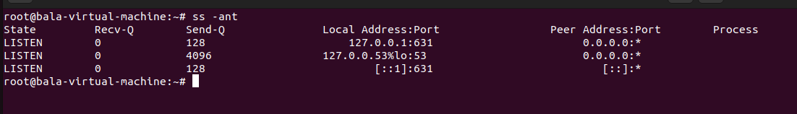

Tcpdump:

The Tcpdump command is used to give the traffic

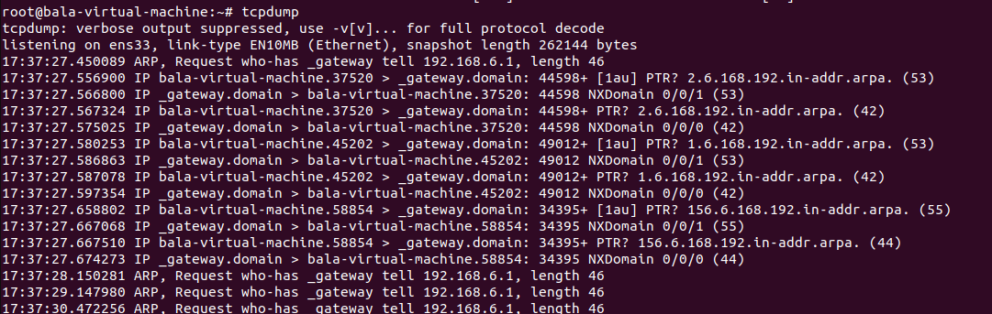

If you want to see particular interface traffic

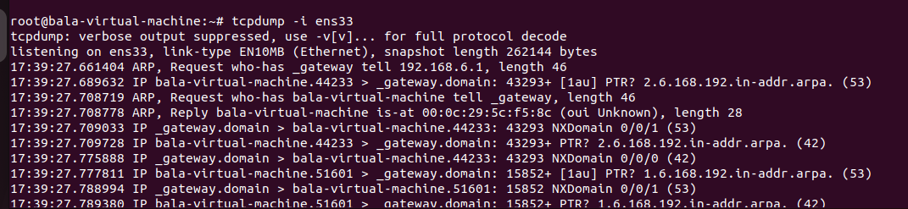

**telnet:**

Telent utilizes the telnet network protocol to connect to remote machines and manage them through a TCP/IP network. The protocol uses port 23 to establish a connection and provides a way to manage remote systems using the CLI.

**telnet ip-address portnumber**

**Sudoers:**

The sudoers file is a file Linux and Unix administrators use to allocate system rights to system users. This allows the administrator to control who does what. Remember, Linux is built with security in mind. When you want to run a command that requires root rights, Linux checks your username against the sudoers file.

Create an user :

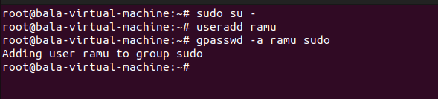

Then use vi sudoers, to add the created user to the file.



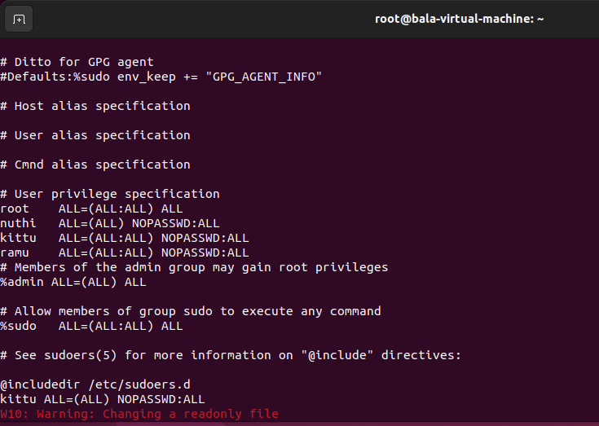

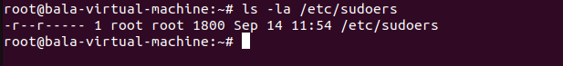

And if you want to change your host name , use the following

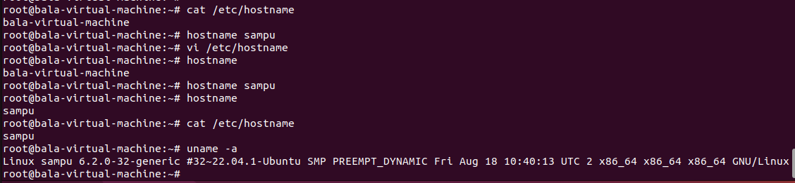

**Curl:**

The **curl** command in Linux is a powerful tool for making HTTP requests and interacting with web services and resources. It allows you to **retrieve** **and send data to and from URLs** using various protocols like HTTP, HTTPS, FTP, SCP, and more. Here's the basic syntax of the curl command:

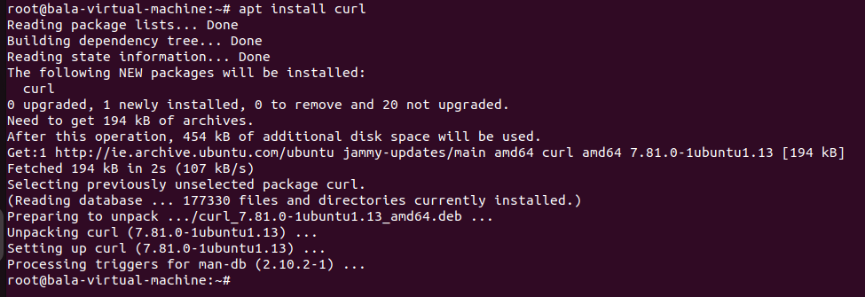

Once it will install , use help command

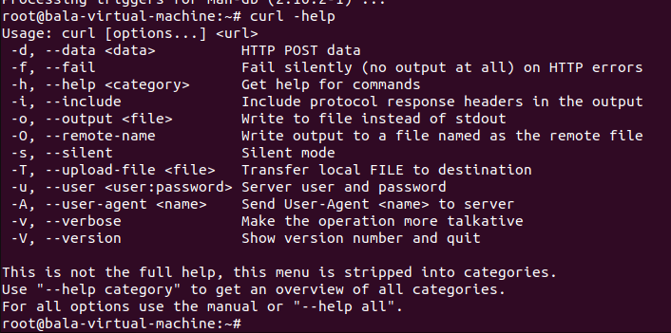

If you want to get the content from the google, use the following command

Using curl

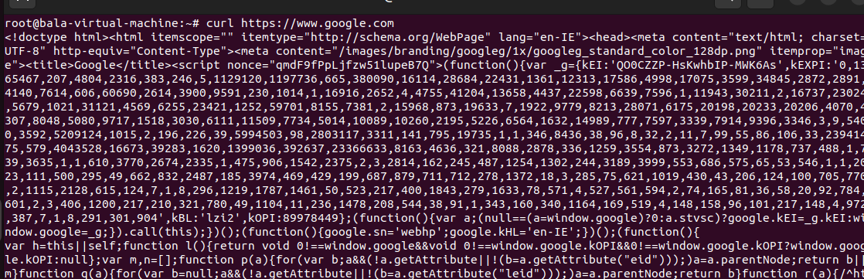

If you want to get the content and save it in one file with html extension use the following command.

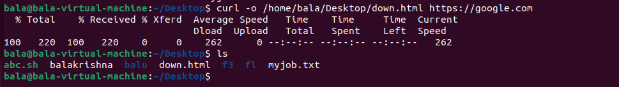

And if you want to see the **cookies and header** information. use the following command

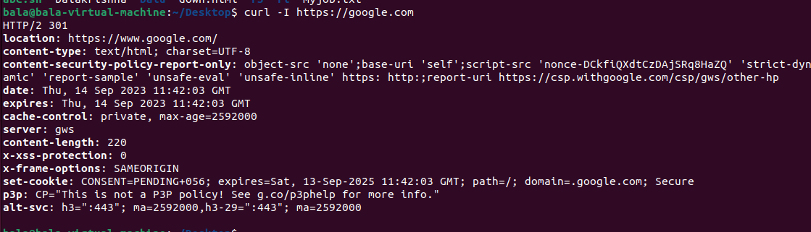

For redirection use -L option and **Sending a POST request with data**:

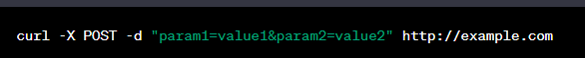

**Setting headers**:



**Using basic authentication**:

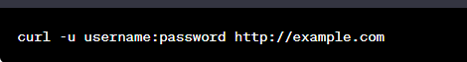

And for uploading a file

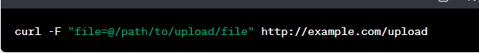

And sending a **Json** request



Wget:

The wget command in Linux is used to download files from the internet, supporting various protocols like HTTP, HTTPS, FTP, and FTPS. It's a versatile tool for downloading files and is commonly used in shell scripts and for batch downloads.



**Continuing an interrupted download**:

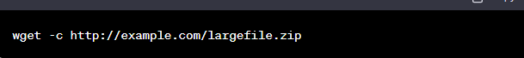

**Downloading multiple files from a file**:

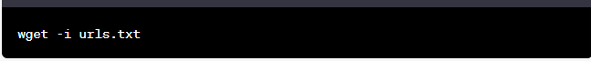

**Downloading recursively (e.g., entire websites)**:

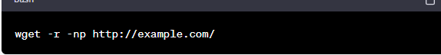

**Downloading via FTP with a username and password**:



**Downloading over a secure connection (HTTPS)**:



**Services :**

To list all services, use the

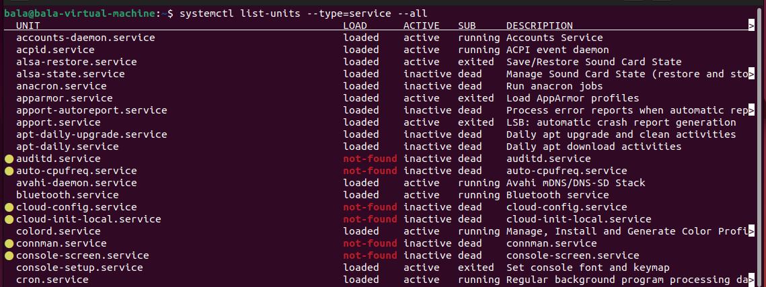

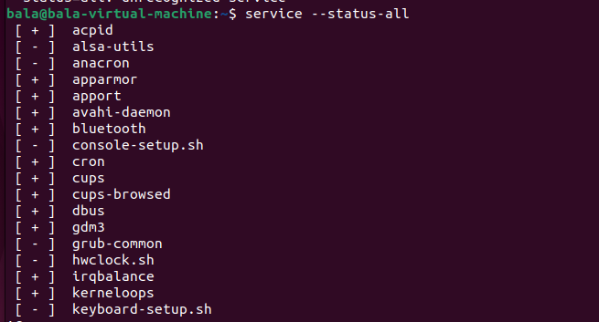

To check running services .. use the following and same like you can try active, in-active and loaded and unloaded etc

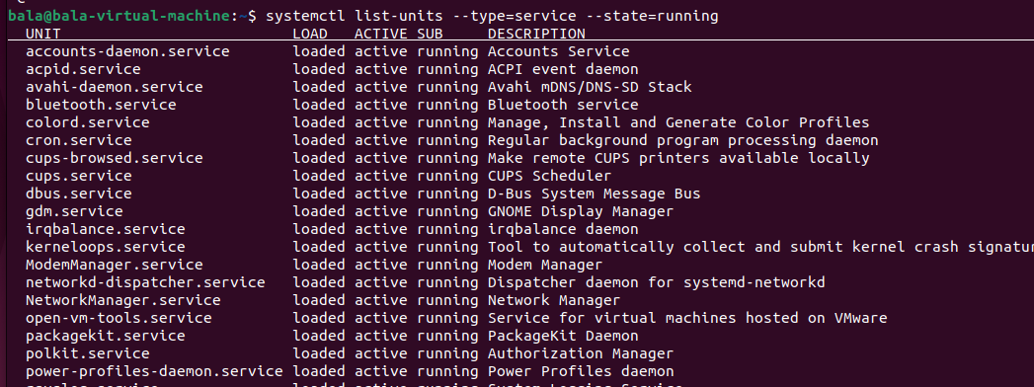

install the nginx server and check the status of the service and restart the service once it is configured using the following commands.

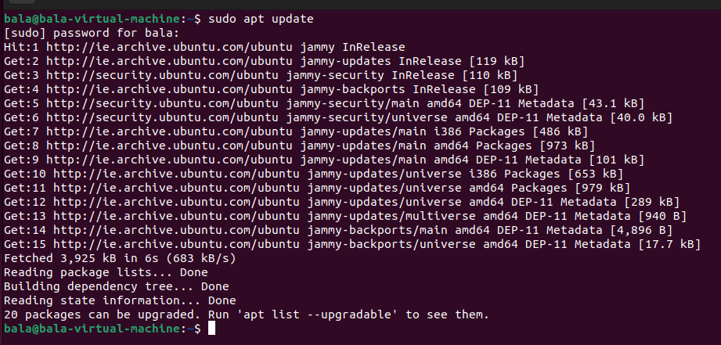

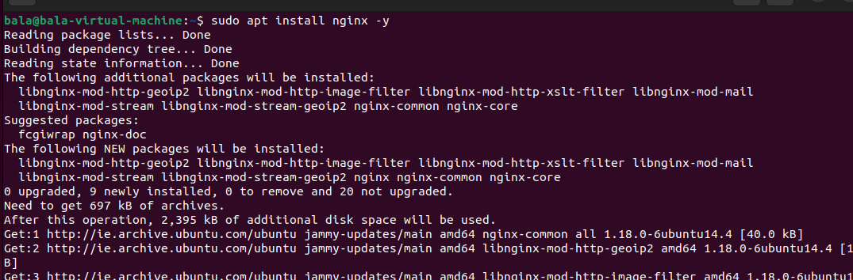

Linux based operating systems use bash shell. The shell environment variable used for several purposes like storing data, storing software configurations, locating terminal settings etc..

Press , **set** and then enter .. it will list out the all the environment variables stored in the shell.

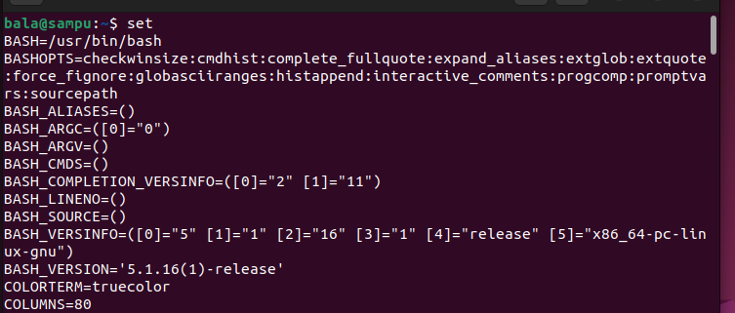

To add or modify the environment variables, use the **export** command.

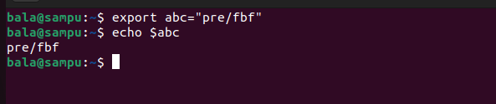

**Shell script:**

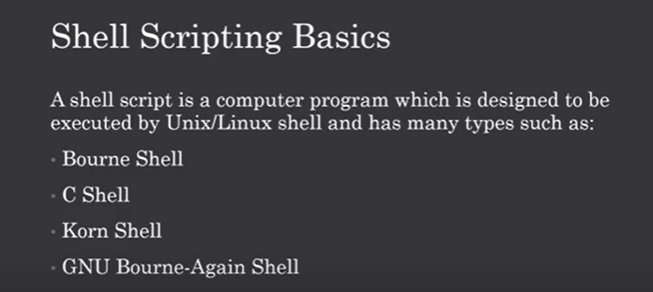

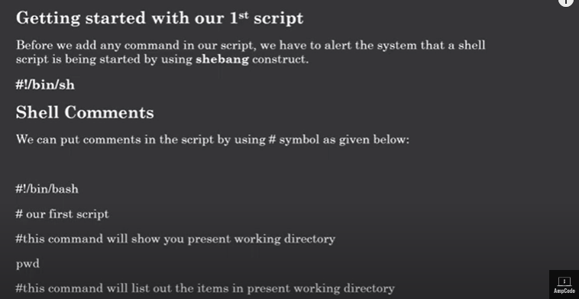

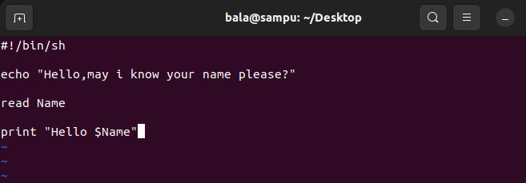

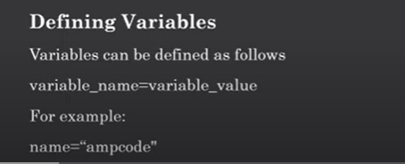

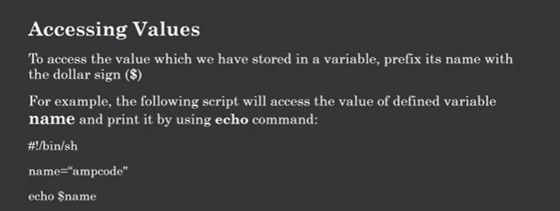

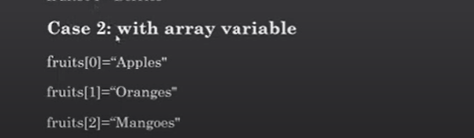

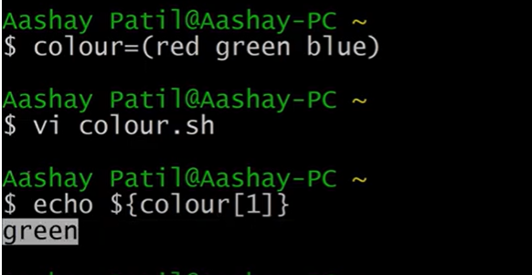

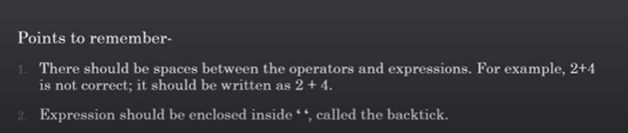

If you want to see list of shells available , use the and the next command is to help to search where the bash shell located?

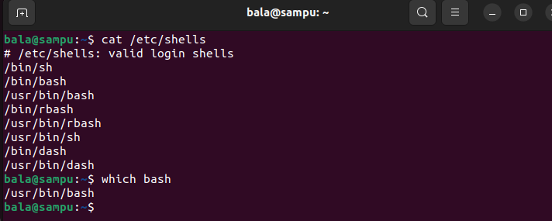

Lets execute the “hello world” program from the bash shell scripting.

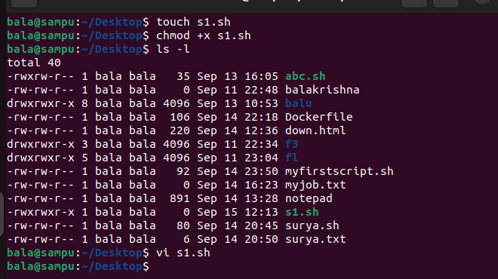

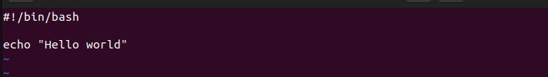



Variables are containers to store the data.

There are 2 types of variables one is **system variables** and other one Is **user defined variables.**

System variables are created and maintained by Linux or Unix system and user defined variables are created by users.

System variables are created with **capital letters** and for user-defined variables are created with **small letters**.

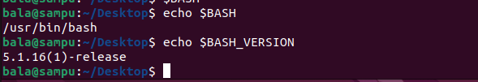

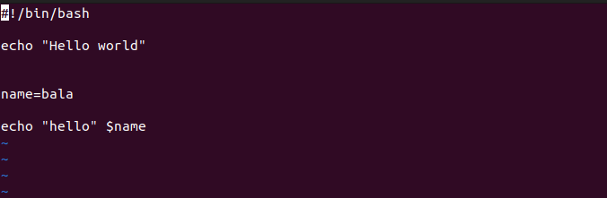



**Read user input:**

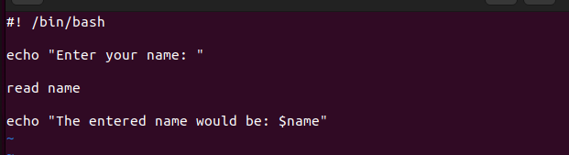

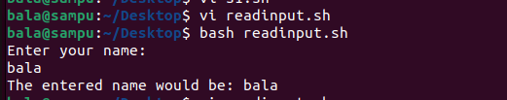

Read multiple variables:

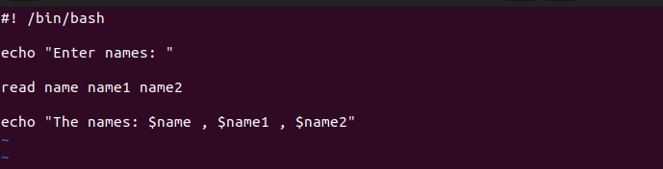

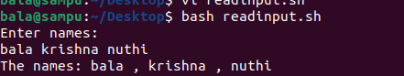

If you want to enter the input on the same line, use the “p” flag with read command

Read -p “username: ” usernm

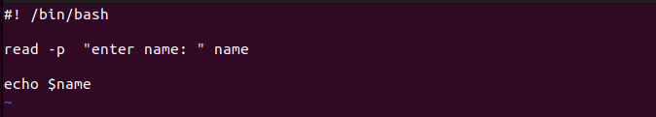

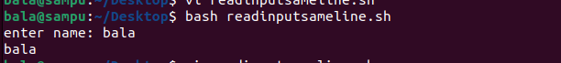

The next option is silent “s”,

If you want to enter password, by that time don’t want to show password on screen use this option

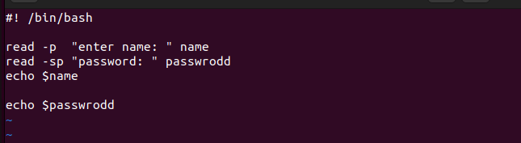

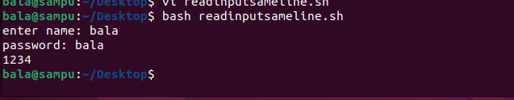

By default your input goes to the built-in variable called “REPLY”

**Pass arguments to the shell script:**

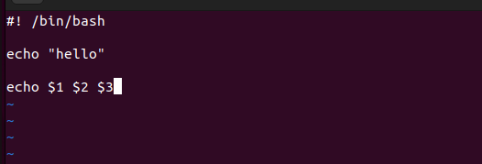

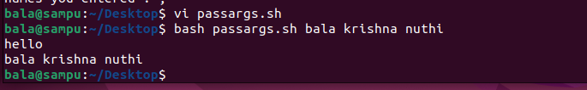

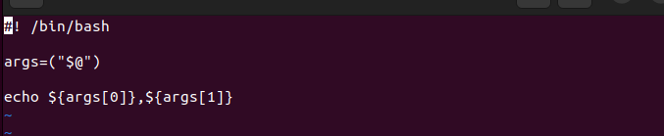

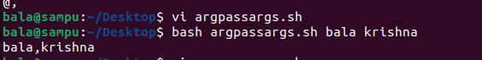

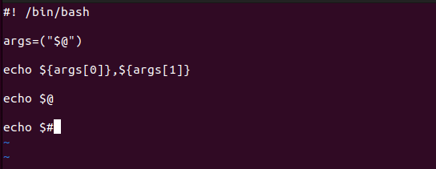

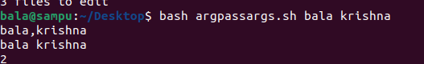

**If condition:**

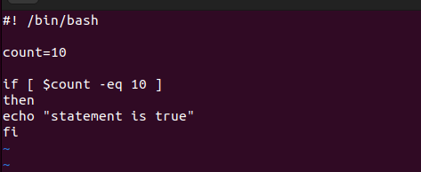

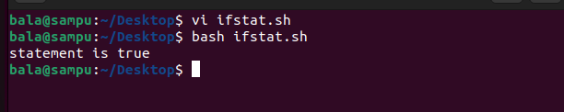

**If-else:**

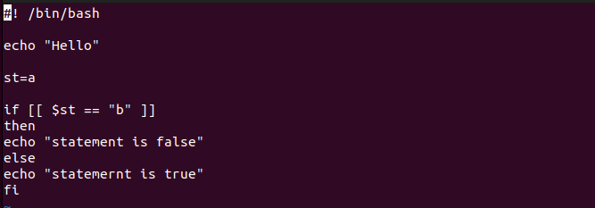

Output:

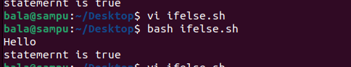

**If-elif-else:**

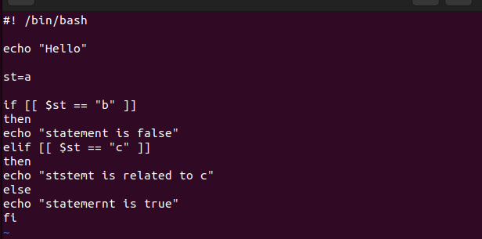



**Test the file if exist or not:**

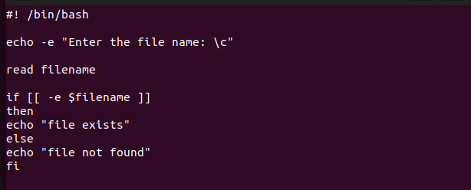

Here echo -e \c options help to **enable** the **cursor** at “enter the file name”

And if condition -e would be for “exist”

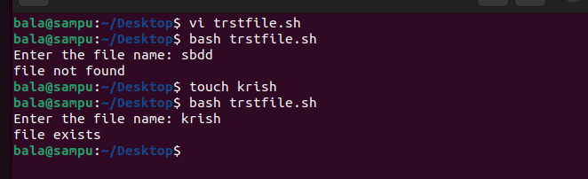

Like that, you can check if the given file is a file or not using -f option.

And for directory check use the -d instead

And for block file use the -b

And for character file use the -c

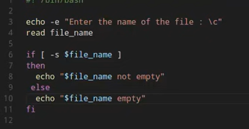

Here -s option checks if the file is empty or not

And check if your file has read option using -r and write permission check with -w and for -x execute permission .

And if file exist and check -w write permissions on that file and append some data to the file.

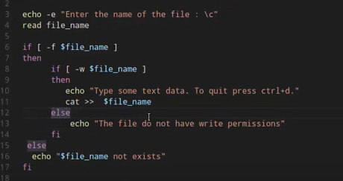

Logical and:

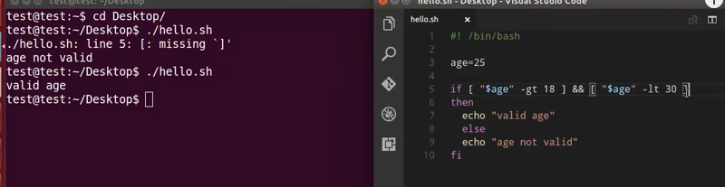

Logical OR:

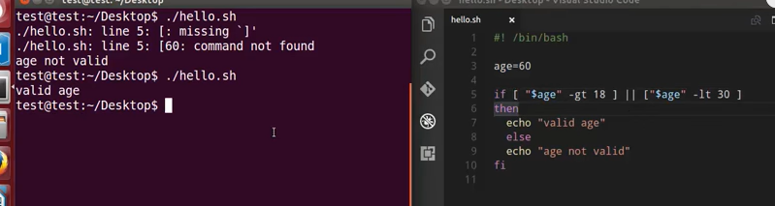

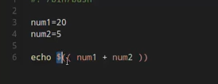

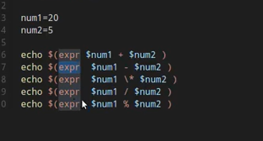

Floating point operations:

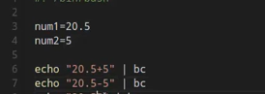

**Case**

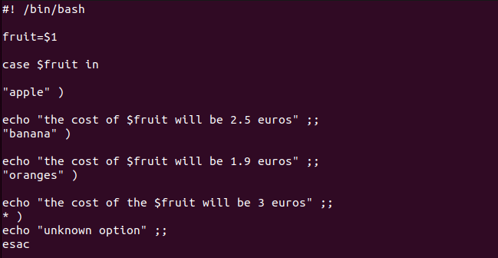

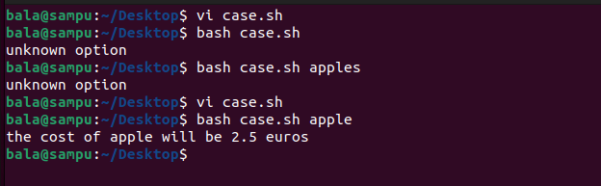

Other example:

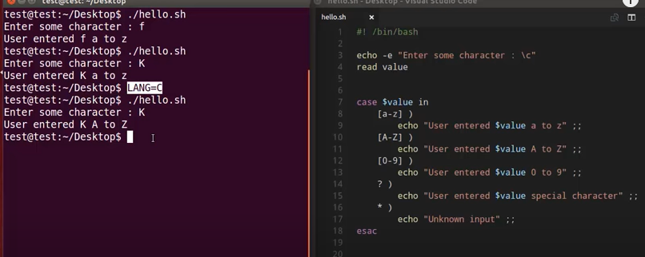

Arrays:

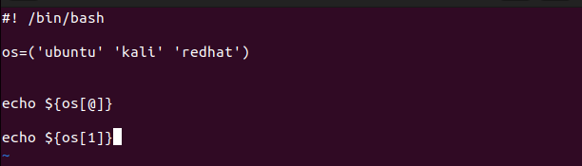

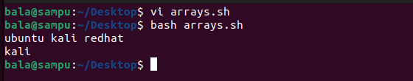

If you want to print the index values of the array use

**Echo “${!os[@]}”**

**Output:**

**0 1 2**

If you want to print the length of the array use the

**Echo “${#os[@]}”**

**Output:**

**3**

If you want to remove the value from the array by index

**Unset os[2]**

**While loop:**

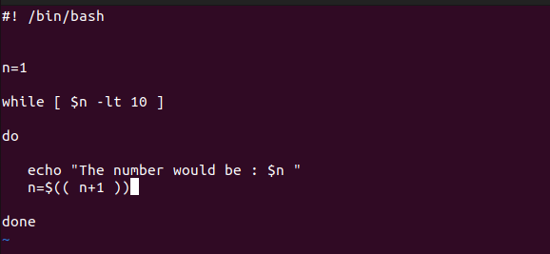

Output:

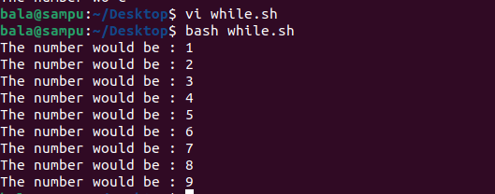

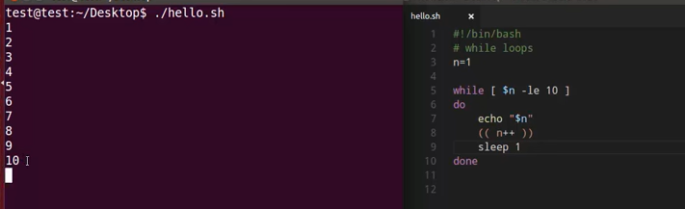

Read the file:

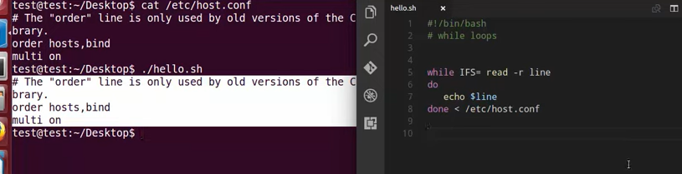

Until:

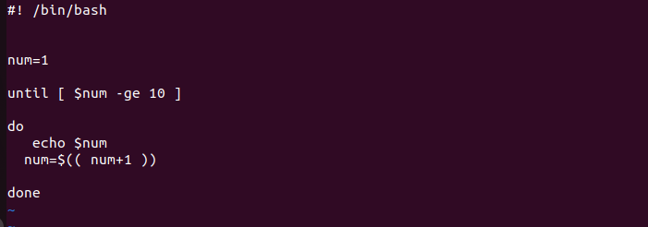

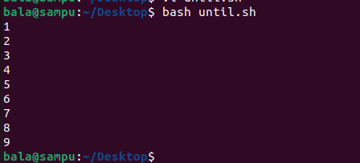

**For loop:**

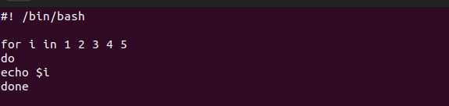



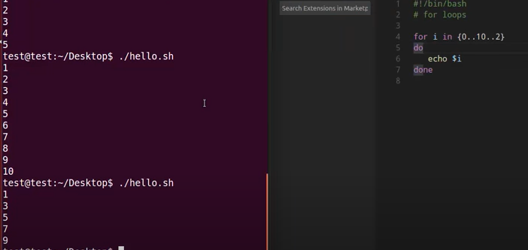

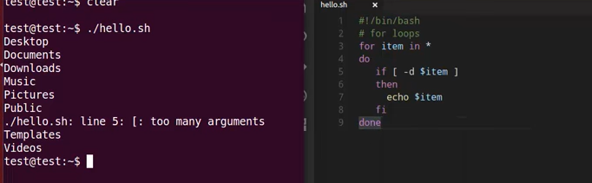

**Select:**

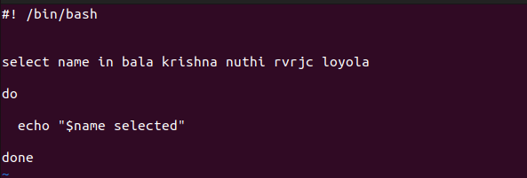

**Output:**

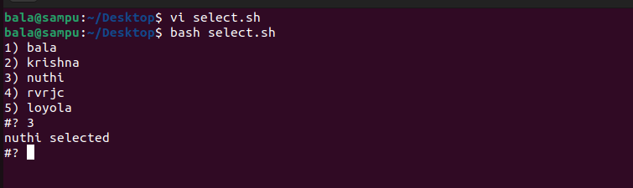

**Select wit case:**

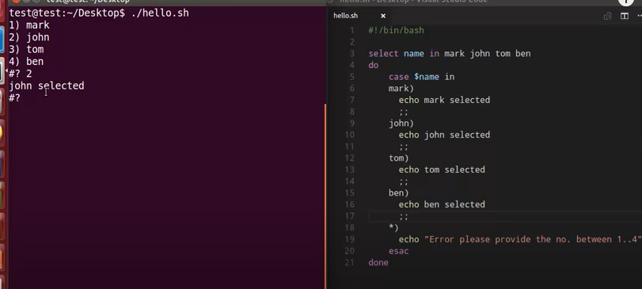

**For loop with break:**

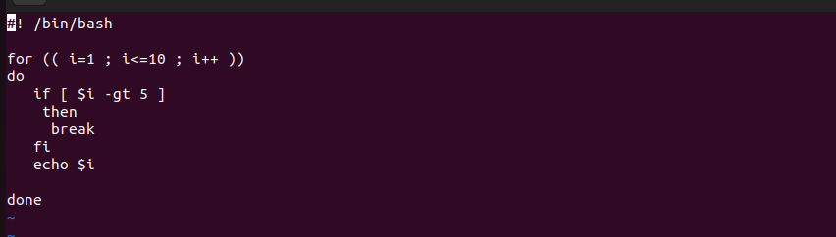

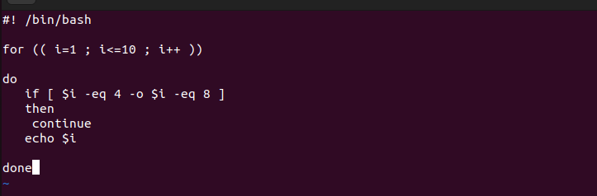

**For loop with Continue:**

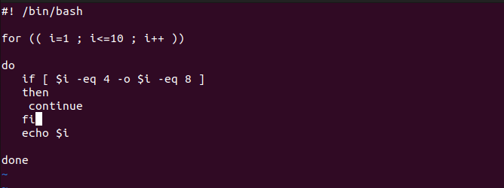

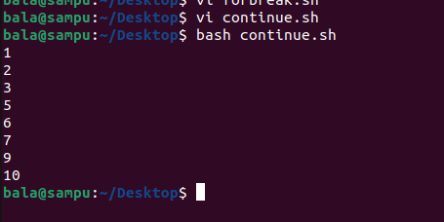

**Creating sample function :**

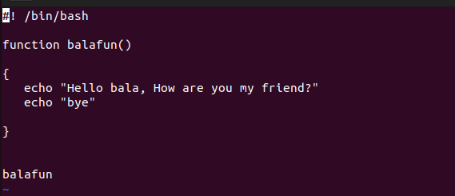

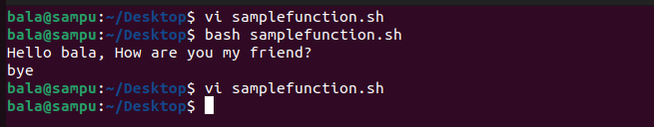

**Function with arg:**

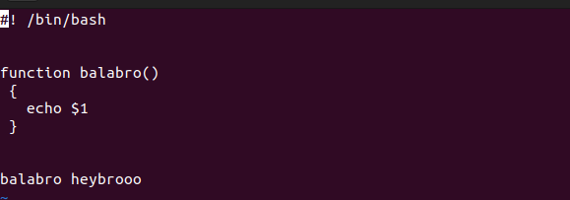

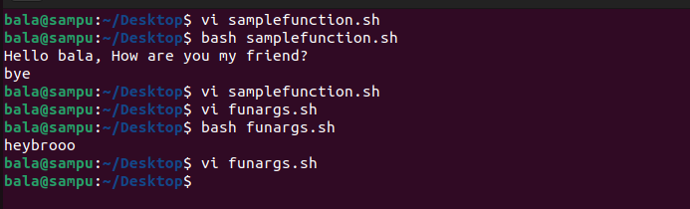

**Function calling output** 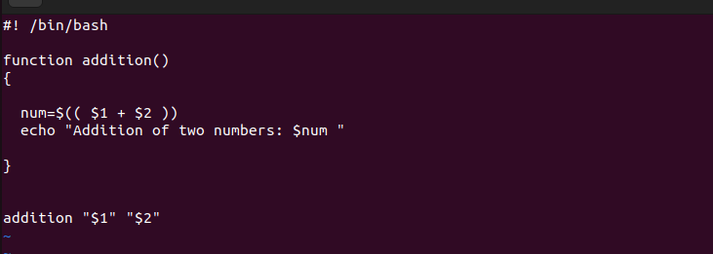

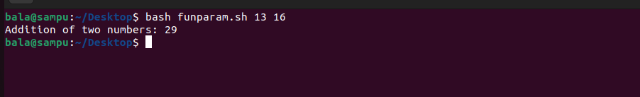

**Nginx-setup:**

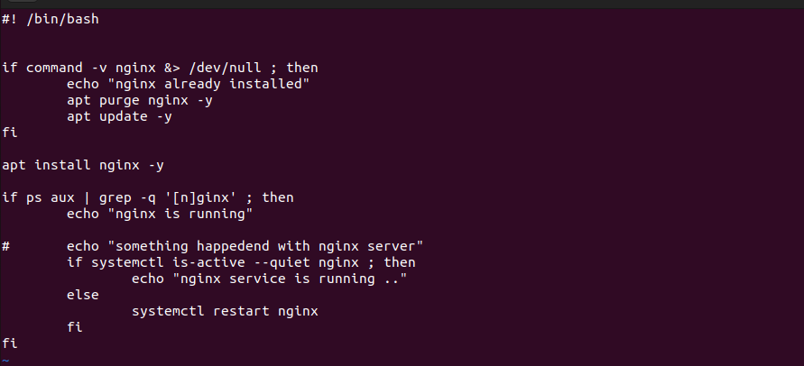

**here "command -v nginx" is a command that checks if the nginx command is available in the system's PATH.**

**This part of the line redirects both the standard output (stdout) and standard error (stderr) to /dev/null. /dev/null is a special file that discards any data written to it. So, if the nginx command is found, any output or error messages it generates will be discarded and not displayed on the terminal.**

**if ps aux | grep -q '[n]ginx' ; then**

**echo "Nginx is running."**

**here**

**ps aux: This part of the line is a command that lists information about currently running processes. When you run ps aux, it displays a list of all processes currently running on the system, along with details about each process, such as its PID (Process ID), CPU usage, and more.**

**grep -q '[n]ginx': This part of the line is a command that searches for a specific pattern in the input it receives via the pipe (|). The -q flag tells grep to operate in "quiet" mode, which means it won't produce any output to the terminal. The pattern it's searching for is [n]ginx, where [n] is used as a workaround to prevent grep from matching its own process when searching for "nginx." The square brackets create a character class and match either "n" or "g."**

